- PROCEDURE TO DISPLAY ALL CUSTOMERS
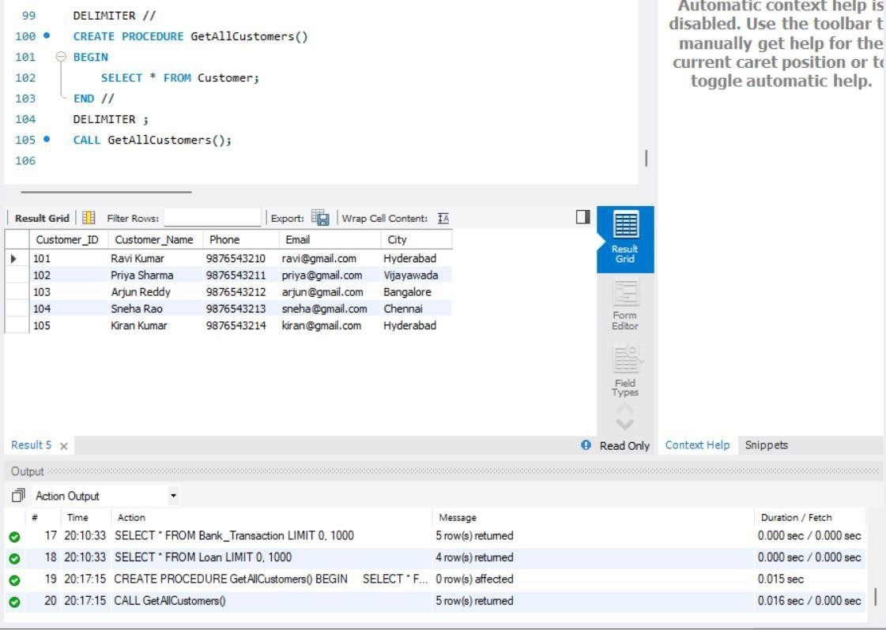
- PROCEDURE TO DISPLAY ACCOUNT DETAILS
FOR A GIVEN ACCOUNT NUMBER
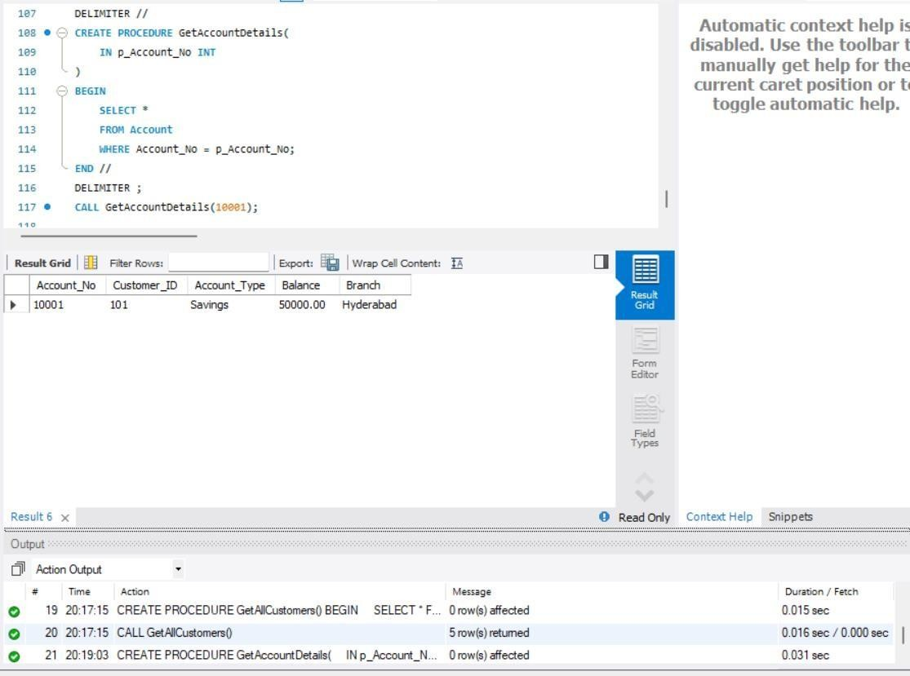
- PROCEDURE TO FIND CUSTOMER ACCOUNTS
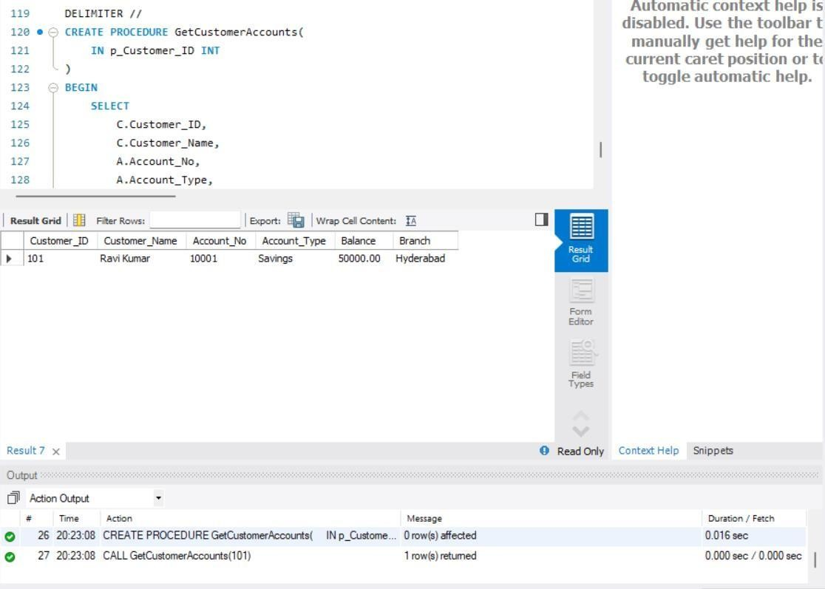
- PROCEDURE TO DEPOSIT MONEY
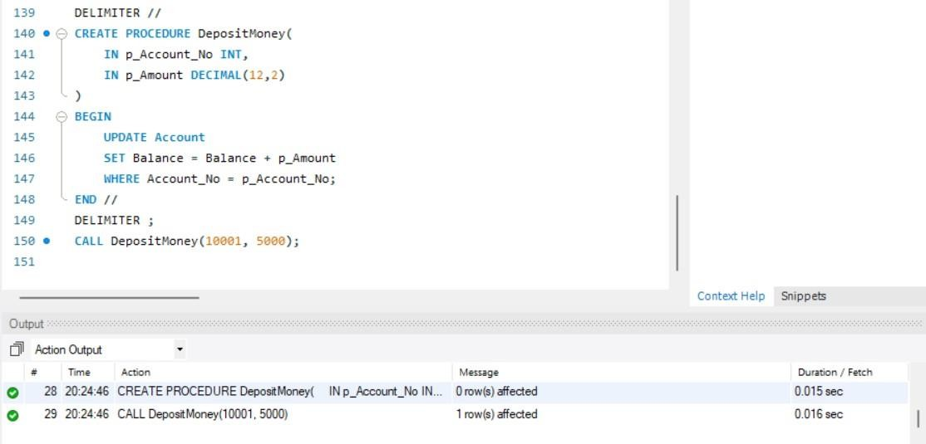
- PROCEDURE TO WITHDRAW MONEY
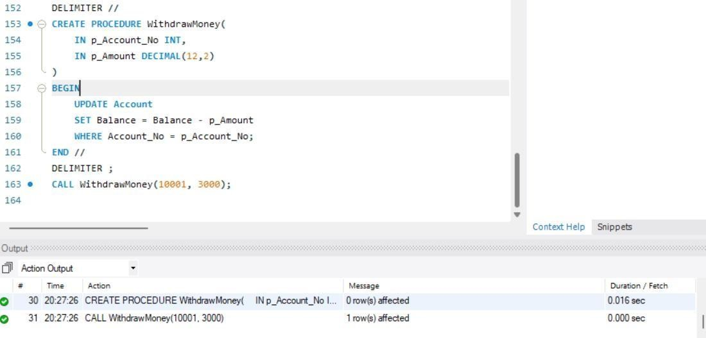
- TRIGGER – PREVENT NEGATIVE BALANCE
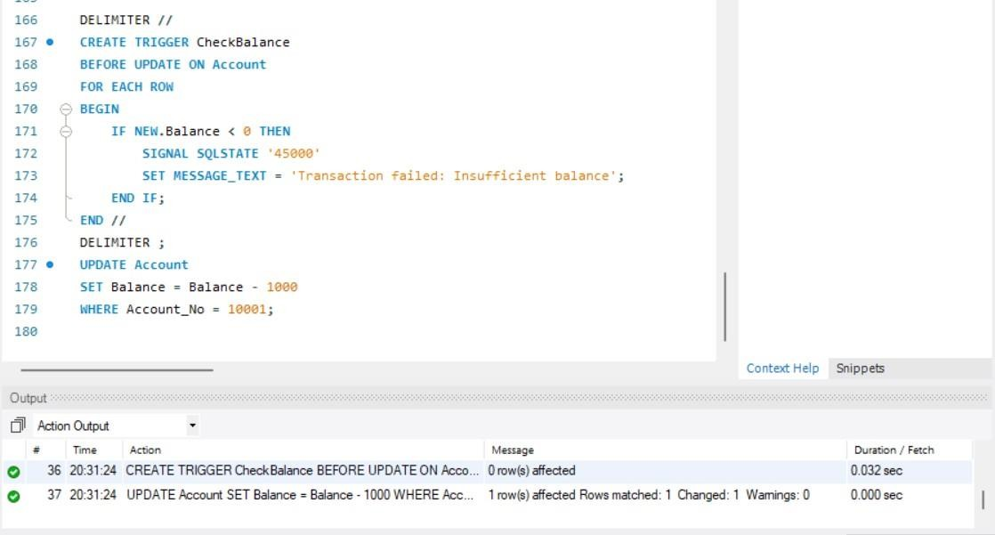
- CREATE TRANSACTION AUDIT TABLE
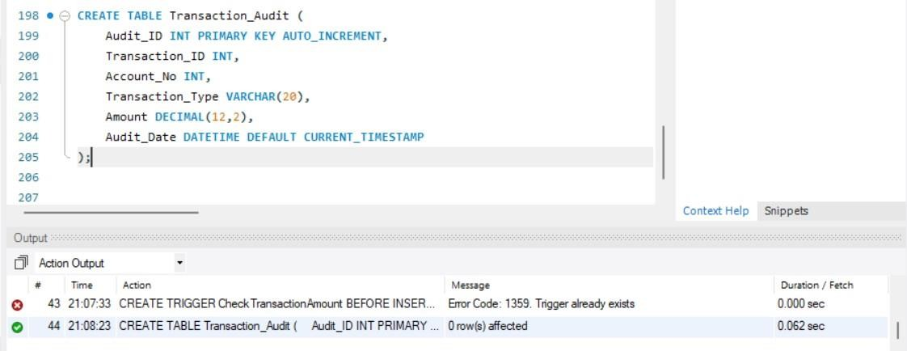
- TRIGGER – TRANSACTION AUDIT
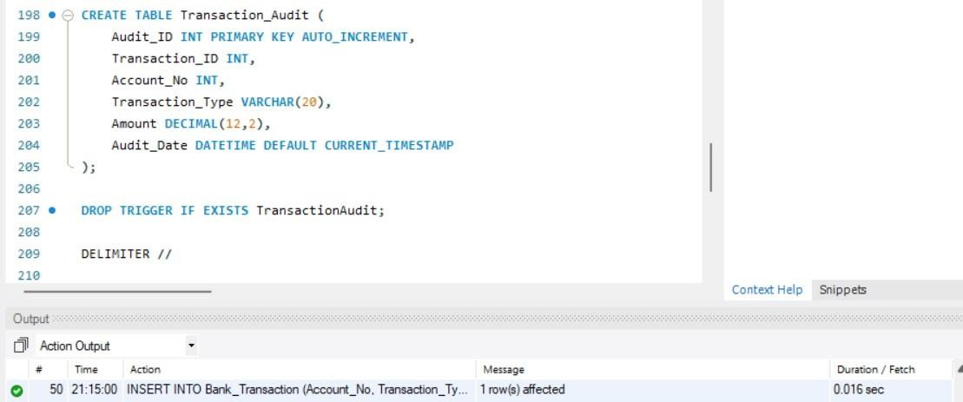
- TRIGGER – TRANSACTION AUDIT
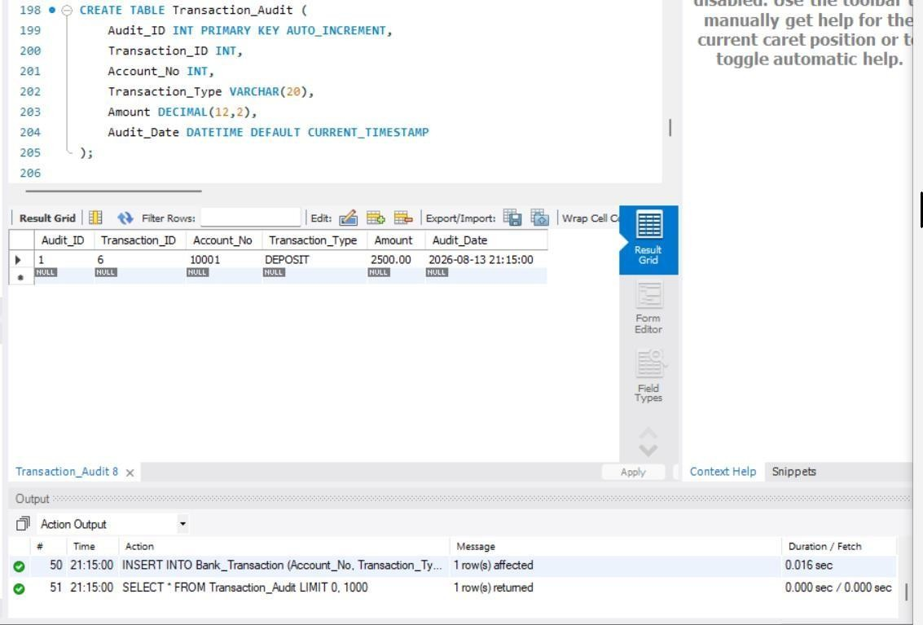
- TRIGGER – AUTOMATICALLY UPDATE ACCOUNT
BALANCE
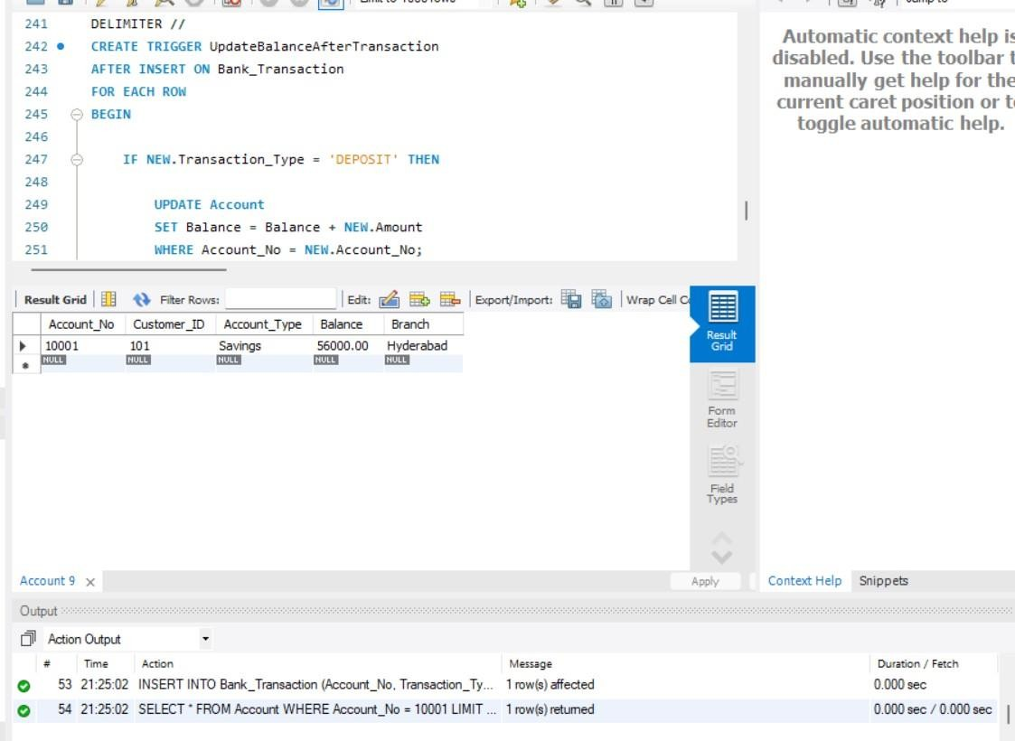
- TRIGGER – PREVENT WITHDRAWAL ABOVE BALANCE
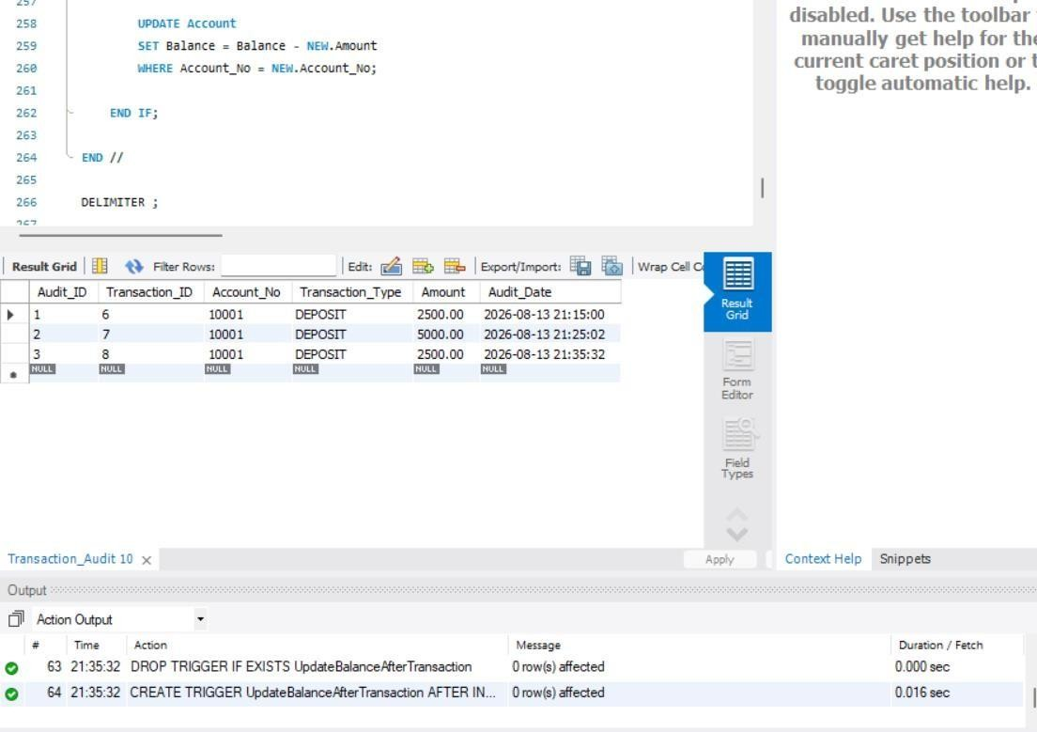
- PROCEDURE – ACCOUNT TRANSFER
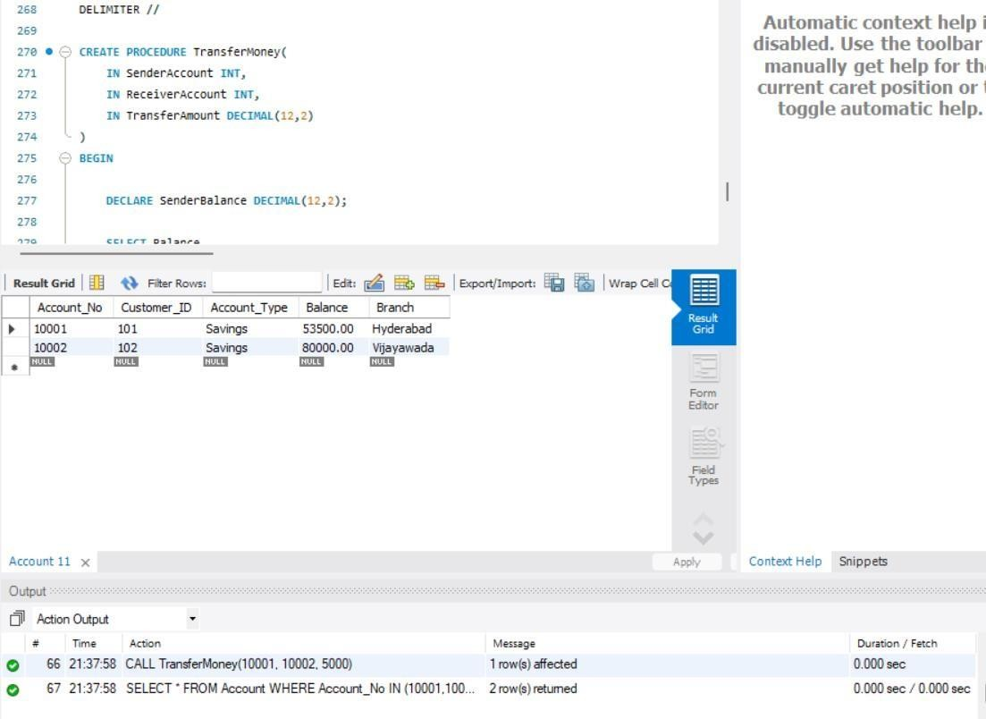
- PROCEDURE – CUSTOMER LOAN DETAILS
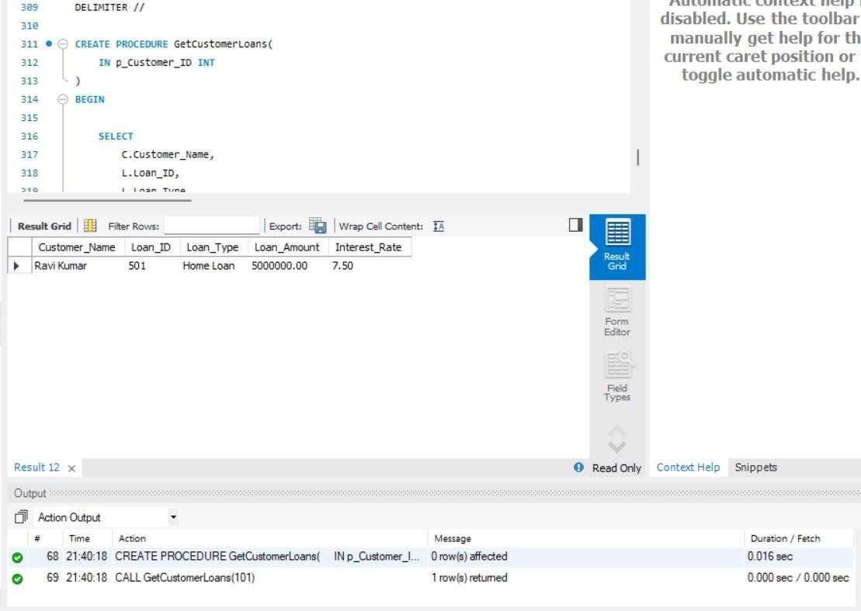
- PROCEDURE – HIGH BALANCE ACCOUNTS
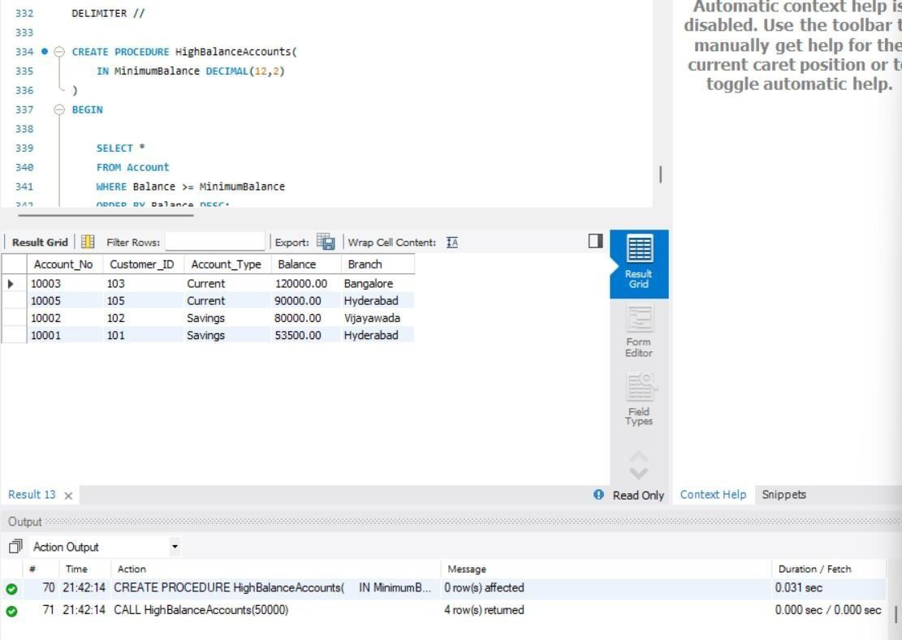
- PROCEDURE WITH IN, OUT PARAMETERS
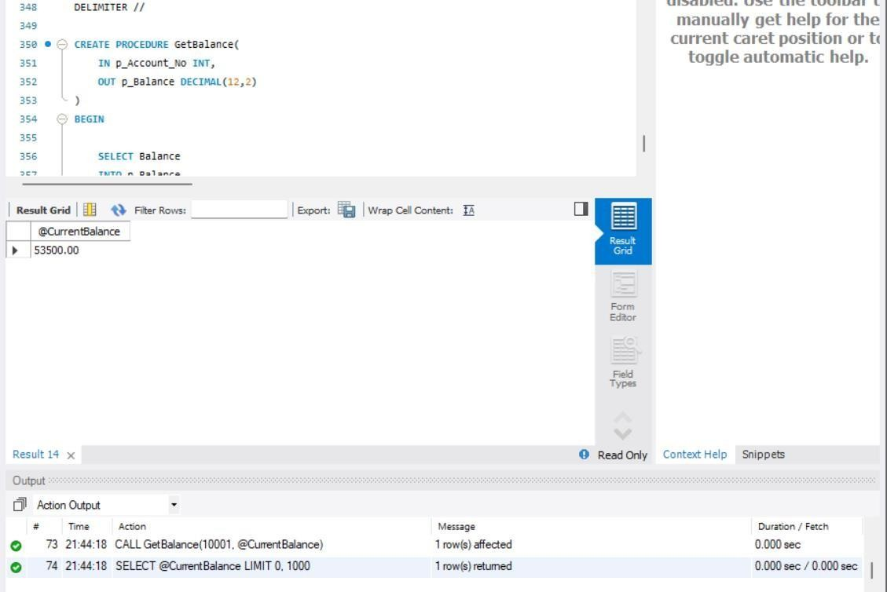
- TRIGGER MANAGEMENT COMMANDS
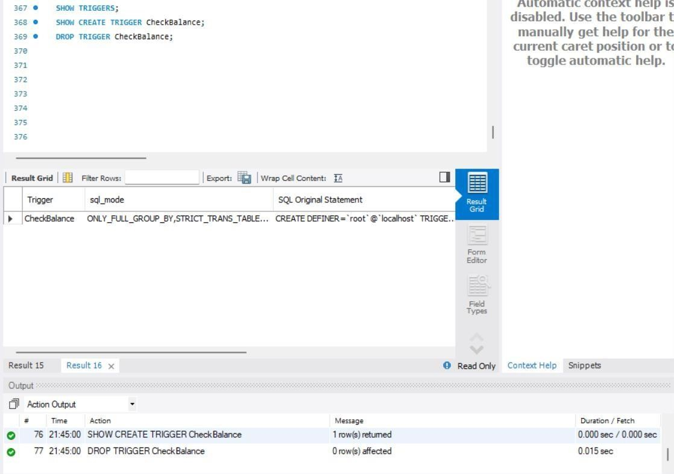
- PROCEDURE MANAGEMENT COMMANDS
